OFFICE STATIONERY REQUEST SYSTEM
@CREATIVITY THINK (9483175986/7019689991)

ABSTRACT:
Office Stationery Request System is a web-based application designed to streamline the management of stationery requests, approvals, and inventory tracking for offices, schools, and colleges. The platform allows employees to browse available items, submit requests with quantities, receive approval notifications, and track past requests. Administrators can manage the item catalog, monitor stock levels, approve or reject requests, and view analytics dashboards. Built using Django and Django REST Framework for backend services, and React with axios and recharts for frontend interactivity, the system provides efficient stock management, approval workflows, and comprehensive usage reporting..

INTRODUCTION OF THE PROJECT:
Organizations often struggle with managing stationery requests due to manual processes, lack of inventory visibility, and inefficient approval workflows. Employees may face delays in obtaining required items, while administrators find it challenging to track consumption and maintain stock. The Office Stationery Request System addresses these challenges by offering a digital platform where requests, approvals, stock levels, and usage analytics are centrally managed. This ensures transparency, timely processing, and data-driven decision-making for stationery management..

PROJECT OBJECTIVES:

• Provide a digital catalog of stationery items
• Enable employees to submit requests with desired quantities
• Implement an approval/rejection workflow for requests
• Track stock levels and alert administrators on low inventory
• Maintain detailed request history for employees
• Provide dashboards and analytics for consumption tracking
• Allow export of monthly usage reports
• Ensure efficient communication between employees and store management
• Support secure and scalable backend APIs

PROBLEM OF THE STATEMENT:
Manual stationery management often leads to delays in fulfilling employee requests, inaccurate stock tracking, and inefficient approval processes. Administrators lack insight into departmental consumption, making it difficult to optimize inventory or budget allocations. The Office Stationery Request System solves these issues by providing an organized digital platform for managing requests, tracking stock, and generating analytics, thereby improving operational efficiency and transparency..

MOTIVATION OF THE PROJECT:
• To automate stationery request and approval workflows
• To reduce delays and improve employee satisfaction
• To maintain accurate records of stock and consumption
• To identify low-stock items and prevent shortages
• To provide actionable insights through dashboards and reports
• To enable better planning and resource allocation
• To streamline communication between employees and administrators
• To create a scalable, secure, and user-friendly system

BLOCK DAIGRAM OF PROJECT:

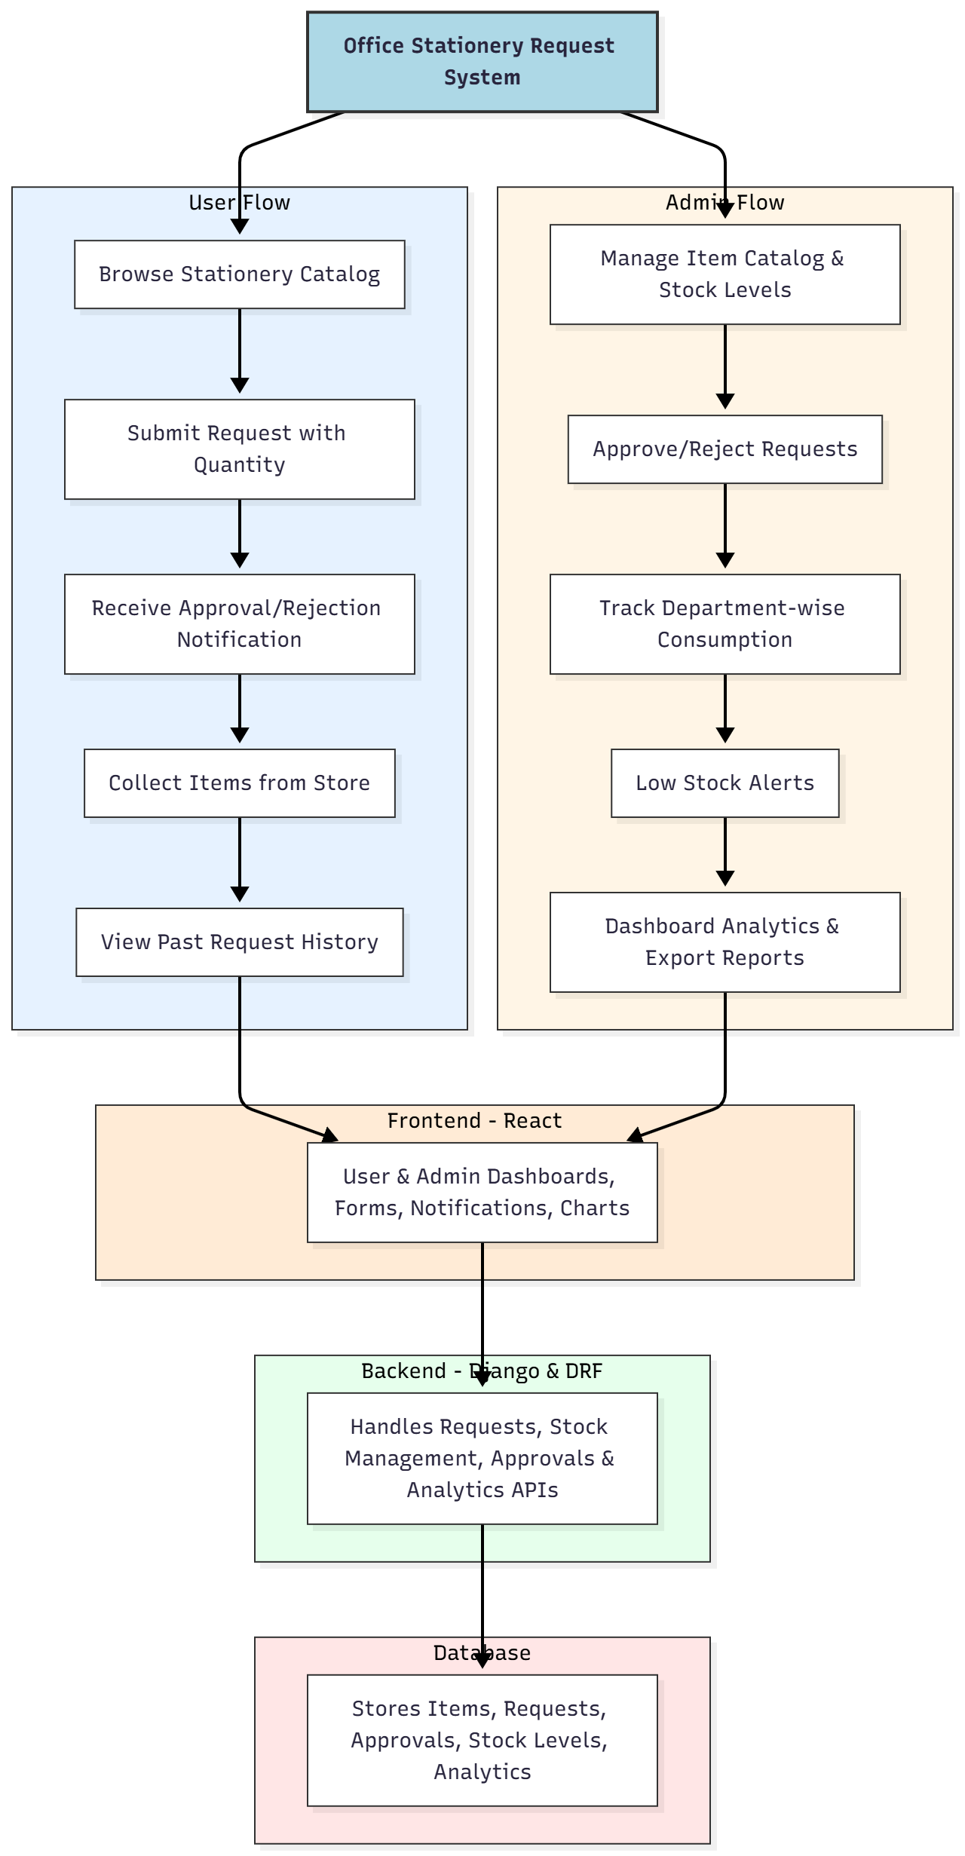

WORKING OF THE PROJECT:
Employees browse the catalog to select required stationery items and submit requests specifying quantities. Requests are sent to administrators who can approve or reject them based on stock availability. Notifications are sent to employees about the status of their requests. Once approved, items are collected from the store, and all requests are logged for historical tracking. Administrators manage the catalog, monitor stock levels, receive alerts for low inventory, and analyze department-wise consumption using dashboards. Monthly usage reports can be exported for record-keeping and decision-making..

SOFTWARE REQUIREMENT:
- Backend:
  - Python 3.x
  - Django
  - Django REST Framework
  - SQLite/PostgreSQL
- Frontend:
  - Node.js and npm
  - React.js
  - Axios
- Development Tools:
  - Visual Studio Code
  - Postman (for testing APIs)
  - Git/GitHub (for version control)
- Server/Deployment (Optional):
  - Gunicorn, Nginx, or Heroku/AWS for hosting

ADVANTAGES OF THE PROJECT:

• Streamlines stationery request and approval workflows
• Provides real-time stock tracking and low-stock alerts
• Reduces delays and manual paperwork
• Maintains accurate departmental consumption records
• Offers analytics dashboards for better planning
• Generates monthly usage reports for documentation
• Improves employee satisfaction and operational efficiency
• Scalable and secure platform for institutional use

APPLICATIONS OF THE PROJECT:
• Corporate offices
• Schools and colleges
• Government departments
• Institutional offices requiring inventory management
• Any organization with recurring stationery needs

REFERENCES:

- Django REST Framework Documentation — Django Software Foundation. Django Documentation. Available: https://docs.djangoproject.com/
- Django REST Framework. DRF Documentation. Available: https://www.django-rest-framework.org/
- React. React Official Documentation. Available: https://reactjs.org/docs/getting-started.html
- Redux. Redux Documentation. Available: https://redux.js.org/introduction/getting-started
- PostgreSQL Global Development Group. PostgreSQL Documentation. Available: https://www.postgresql.org/docs/
- MySQL. MySQL Reference Manual. Available: https://dev.mysql.com/doc/
- Git. Git Documentation. Available: https://git-scm.com/doc
- Node.js. Node.js Documentation. Available: https://nodejs.org/en/docs/
- Axios. Axios Documentation. Available: https://axios-http.com/docs/intro
- Socket.io Documentation – https://socket.io/docs/

